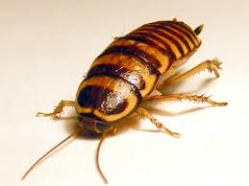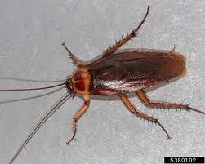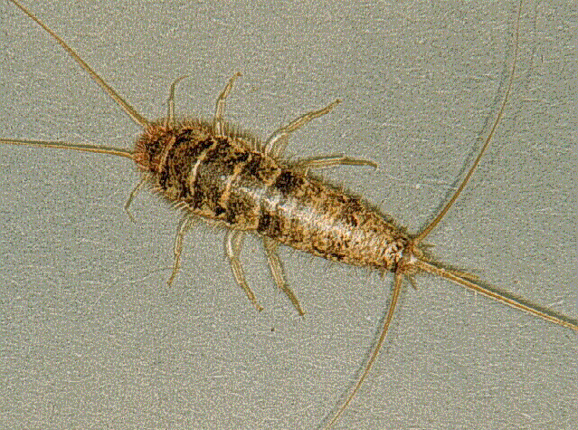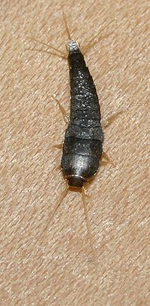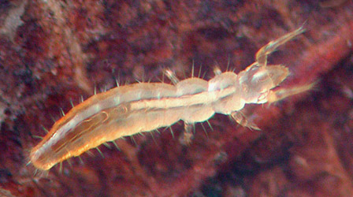

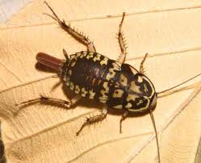

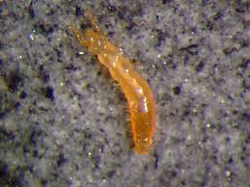

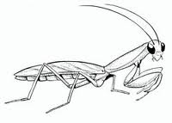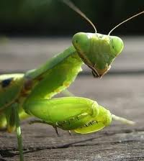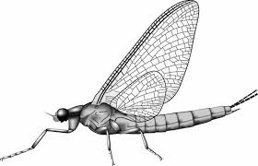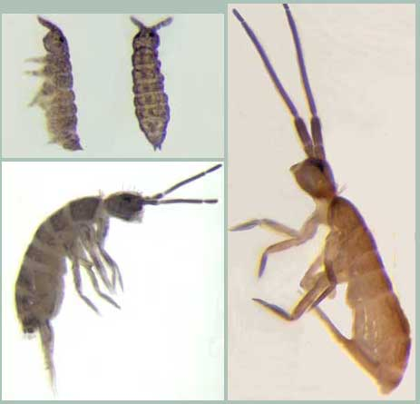

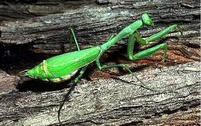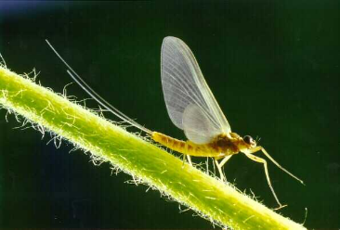

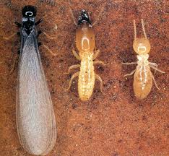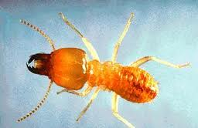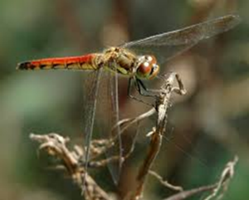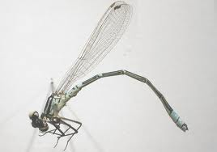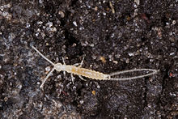

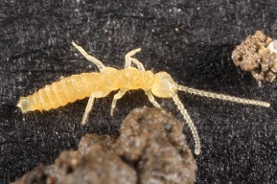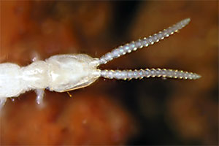

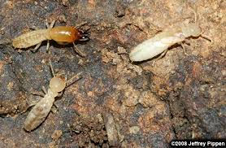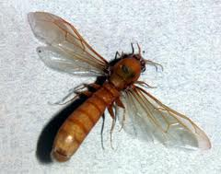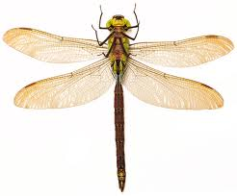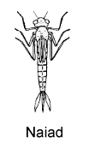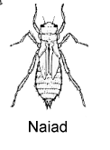



**Blattodea - cockroaches**

Hemimetabola (incomplete development)

Also known as “waterbugs” are scavengers or omnivores

Females lay ootheca a special capsule around the eggs

**Protura – telsontails, proturans**

Soil dwelling

No eyes, wings or antennae

Lack pigmentation

Body elongated and cylindrical

**Thysanura – bristletails, silverfish**

Common in damp places

3 tail-like appendages from their last abdominal segment

Silvery-metallic scales covering their body

**Isoptera - termites**

Hemimetabola (incomplete development)

Closely related to cockroaches

Live in fallen timber and feed on wood fibers

Female provides care for her young offspring

Social behavior

**Diplura**

No eyes

Common in soil

**Mantodea – mantids**

Hemimetabola (incomplete development)

Elongate bodies specialized for predatory lifestyle

Most abundant and most divers in tropics

Cryptic coloration for hiding in foliage or flowers

**Collembola – springtails, snow fleas**

Less than 6mm

Tail-like appendages

Reduce body size by 30%

**Odonata – dragon/damselfies**

Hemimetobla (incomplete development)

Immatures are aquatic

Predators of insects

For families go to 1.

**Ephemeroptera - mayflies**

Hemimetobla (incomplete development)

Immatures are aquatic

Short lifespan (die in a single day)

Unable to fold the wings over the back

Compound eyes

Wings four membranous wings with many veins